COINS-Constantine I (306-337),  AD 317, SOL INVICTO COMITI

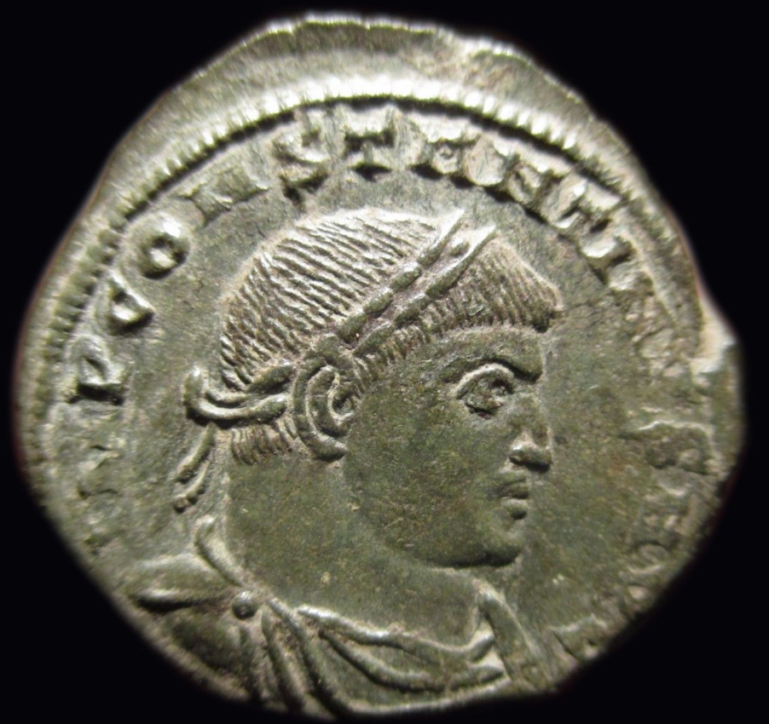 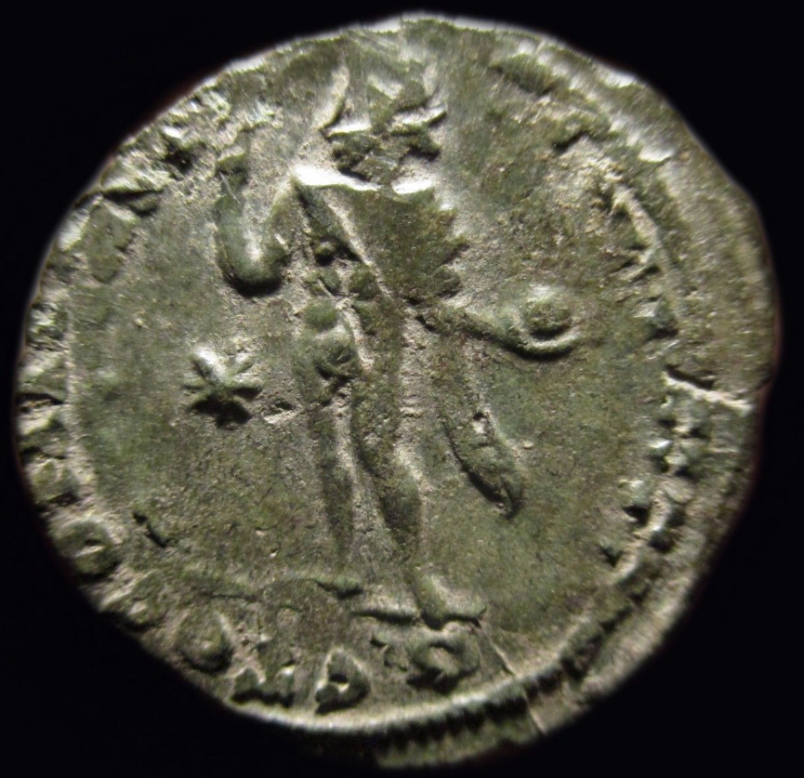

Constantine I (306-337),  AD 317, AE,.

IMP CONSTANTINVS  AVG, laureate and cuirassed bust r.,

 Rv. SOL INVICTO COMITI, Sol standing l., holding globe and raising hand; Star in field

19mm 3.07gr